Guidance Class Lesson for the week of April 20-24

Hello Amazing 2nd graders and families! I miss you all so much!

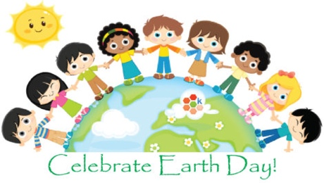

This week, we will continue our study about being kind to our Earth. Earth Day is April 22nd!

Today you will learn about **RECYCLING, REUSING, REDUCING, the 3 big R’s**! While you are reading the books and watching the video below, **think** about what you can recycle at your house and how you could reuse things instead of throwing them away. Also how can you reduce by using less electricity and water?

1.Read “The Earth Book” by Todd Parr. Click the link below the picture.

[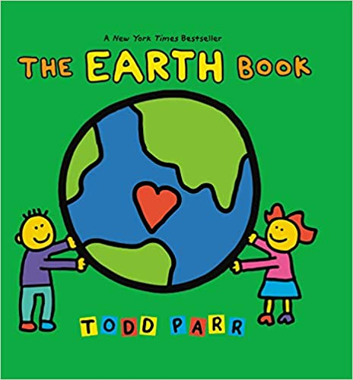](http://www.viewpure.com/lpEc5nHqO2c?start=0&end=0)

2. Read the book, “Why Should I recycle?” by Jen Green.

[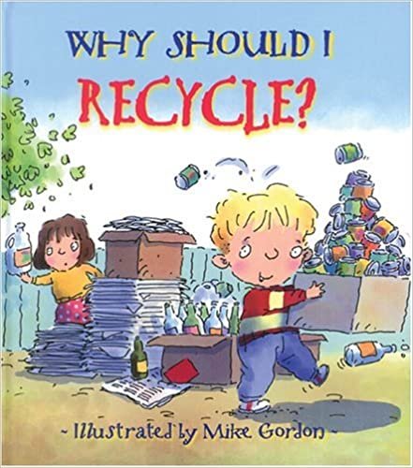](http://www.viewpure.com/mPrSja2FMBI?start=0&end=0)

3. Choose one or more of these 3 activities to do at home. Click [HERE](https://www.leonschools.net/cms/lib/FL01903265/Centricity/Domain/4682/Earth%20day%20activities%20to%20print.pdf) to print the activity sheets to do at home. You can also use a blank piece of paper if you don’t want to print this. You can hang this sheet up in your house to share with your family. Feel free to email me anything you’d like to share with me. Enjoy! If it doesn’t open, click back to see the webpage for printable activities.

Bye-bye now! Let’s take good care of the precious Earth.

